**What is Nodejs?**

Javascript Runtime -

Javascript is a programming language which is typically used in the browser to manipulate the DOM after it was loaded.

Nodejs is a different version of javascript - it is basically built on javascript, adds some features to it.

It takes the Javascript and puts it in a different environment. It allows us to run JS on the server. So it basically allows to run JS not just in the browser but anywhere else like a normal PLs.

Nodejs uses V8 - JS engine built by google that runs JS in the browser.An engine takes JS code the code and compiles it to the machine code that ultimately runs on the machine.V8 itself is written in C++. Nodejs takes V8 codebase and adds certain features like - working with local file system (which is not possible in the browser for security reasons)

**Install Nodejs**

<https://nodejs.org/en/>

Open terminal

$ node -v

$ node (REPL)

Visual Studio Code

Ctrl+ Shift + P/Command + Shift + P (windows/mac)

Color Theme > Dark Theme (default)

View > Extensions > Install “Material Icon Theme”

View > Terminal

**Understanding the Role and usage of Nodejs**

Users using client which is typically a browser. They visit a page let say <http://my-page.com.> Now here a server comes into play. A server is a computer which has IP associated with the domain which is automatically resolved for us. On the server we then execute some code that does something with the incoming request and returns a response. Often but not always this response is a HTML page which the browser then can display. This HTML can also have CSS files or Javascript files. On the server we typically do tasks which we can’t or don’t want to do in the browser for performance or security reasons. For examples connect to DBs, user authentication, input validation, business logic.

So this is where we are going to use Nodejs - we will write code on the server that will returns data our users/clients can work with.

*Note: Nodejs is not limited to run code only on the server. It’s a JS run time and can be used for more than just server side code. For examples - Utility, Scripts, Build Tools - Webpack, etc.*

Nodejs role in Web development:

* Run Server - Create server and listen to incoming requests.
* Business Logic - Handle requests, Validate Input, Connect to database.
* Responses - Return responses (HTML, JSON, files)

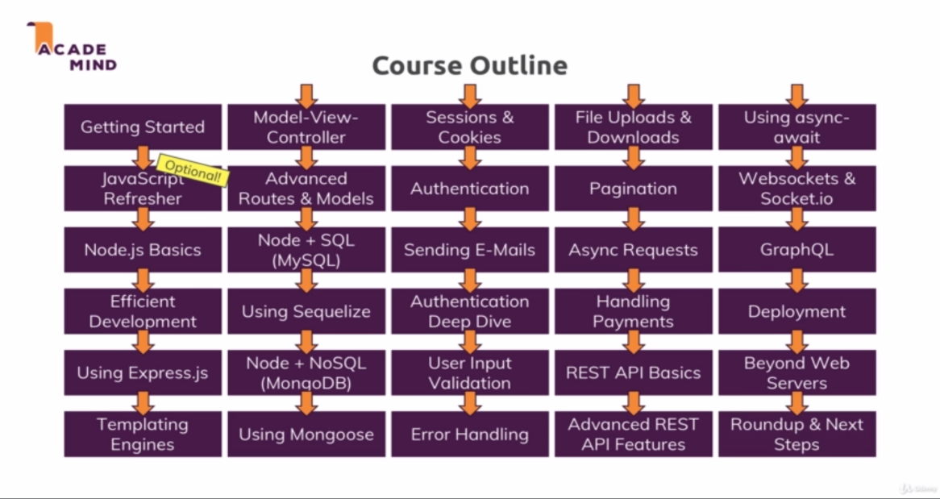

**The REPL**

Read - Read User Input

Eval - Evaluate User Input

Print - Print Output(result)

Loop - Wait for new Input

Open command terminal and provide command node to open REPL

$ node

> 2+2

4

> console.log(‘Hello Node’)

Hello Node

Undefined

This REPL is a great playground which we can use to run some commands, to try out certain things because we execute code as we write it.